**SMOKE DETECTOR CUM FIRE EXTINGUISHER USING ARDUINO**

**INTRODUCTION**

Machine is defined as equipment which minimizes human effort, which is the objective of our project. Our project is mainly based on SMOKE DETECTION. A person can’t detect smoke when he/she not present at that place, thus this device comes into use.

Objective of this project is to save HUMAN LIFE. This device has profound effect in arena of safety with some more advanced system (USING ARDUINO) installed with it.

**WHY DID WE DECIDE TO MAKE THIS PROJECT?**

Our device saves human life as well as human effort and time. The life of this device is comparatively longer as it works on simple mechanism. Though this device is a bit costly, it is worthy of its cost.

**MATERIALS (HARDWARE)**

|  |  |  |  |
| --- | --- | --- | --- |
| **Sr. No.** | **Component Name** | **Picture** | **Description** |
| 1. | Arduino Board | https://cdn.solarbotics.com/products/photos/a0266346bdc1b2028b4066554730ddfa/50450-IMG_5222.jpg | The board is equipped with sets of digital and analog input/output (I/O) pins that may be interfaced to various expansion boards (shields) and other circuits. The board features 14 Digital pins and 6 Analog pins. |
| 2. | Piezoelectric buzzer | Image result for piezoelectric buzzer | Light weight, simple construction and low price make it usable in various applications. Piezoelectric buzzer is based on the inverse principle of piezo electricity. |
| 3. | DC motor | Image result for dc motor | It converts direct current electrical energy into mechanical energy. The most common types rely on the forces produced by magnetic fields. |
| 4. | Battery and battery holder | https://i.ytimg.com/vi/7BYOO5u9Tz0/maxresdefault.jpg | It is electrochemical cell that transforms chemical energy into electricity. It is used to provide power to circuit. |
| 5. | Light Emitting Diode (LED) | Image result for LED | A light-emitting diode (LED) is a two-lead semiconductor light source. It is a p–n junction diode that emits light when activated. |
| 6. | Breadboard | Image result for breadboard | A breadboard is a solderless device for temporary prototype with electronics and test circuit designs. Most electronic components in electronic circuits can be interconnected by inserting their leads or terminals into the holes and then making connections through wires where appropriate. |
| 7. | Printed Circuit Board (PCB) | Image result for PCB | A printed circuit board (PCB) mechanically supports and electrically connects electronic components or electrical components using conductive tracks, pads and other features etched from one or more sheet layers of copper laminated onto and/or between sheet layers of a non-conductive substrate. |
| 8. | Water Tank |  | A water tank stores water to be used to extinguish fire (when needed). |
| 9. | Carbon Monoxide Gas Sensor | Related image | This is a simple-to-use Carbon Monoxide (CO) sensor, suitable for sensing CO concentrations in the air. The MQ-7 can detect CO-gas concentrations anywhere from 20 to 2000ppm. |
| 10. | NPN Transistor | Image result for npn transistor | NPN is one of the two types of bipolar transistors, consisting of a layer of P-doped semiconductor (the "base") between two N-doped layers. A small current entering the base is amplified to produce a large collector and emitter current. |
| 11. | Water Pipe |  | It helps in transportation of water from water tank. |
| 12. | Resistors | Image result for resistor | A resistor is a passive two-terminal electrical component that implements electrical resistance as a circuit element. In electronic circuits, resistors are used to reduce current flow, adjust signal levels, among other uses. |

**MATERIALS (SOFTWARE)**

**Arduino IDE**

The open-source Arduino Software (IDE) makes it easy to write code and upload it to the board. It runs on Windows, Mac OS X, and Linux. The environment is written in Java and based on Processing and other open source software. This software can be used with any Arduino board.

**Fritzing**

Fritzing is an open-source hardware initiative that makes electronics accessible as a creative material for anyone. It is a software tool and a community website for Processing and Arduino, fostering a creative ecosystem that allows users to document their prototypes, share them with others, teach electronics in a classroom, and layout and manufacture professional PCBs.

#### **METHOD**

#### Connect gas sensor pins to pin 9, GND and ANALOG IN of Arduino. Gas sensor senses if carbon monoxide level in air is above the indicated level.

#### Connect pins 10 and 12 of Arduino to any two pins of breadboard such that they are connected to positive end of LEDs. Red LED indicates fire and green LED indicates normal conditions.

#### Connect other end of LEDs to Ground end of breadboard.

#### Connect positive and negative ends of battery to breadboard.

#### Connect Power pin of Arduino to positive end of battery on breadboard and GND pin of Arduino to negative end of battery end on breadboard.

#### Connect one end of buzzer to Arduino and the other end to negative of breadboard. Buzzer raises an alarm in case of an emergency.

#### Connect Arduino with resistor, which is connected with transistor. Transistor is connected to positive of breadboard and to one end of DC motor. If the carbon monoxide level exceeds the set value, current flows through transistor which acts as a switch and causes DC motor to function, which raises water from water tank to extinguish fire.

#### Complete the circuit by connecting the other end of DC motor to positive of breadboard.

#### Connect computer code to Arduino.

**SCHEMATICS**

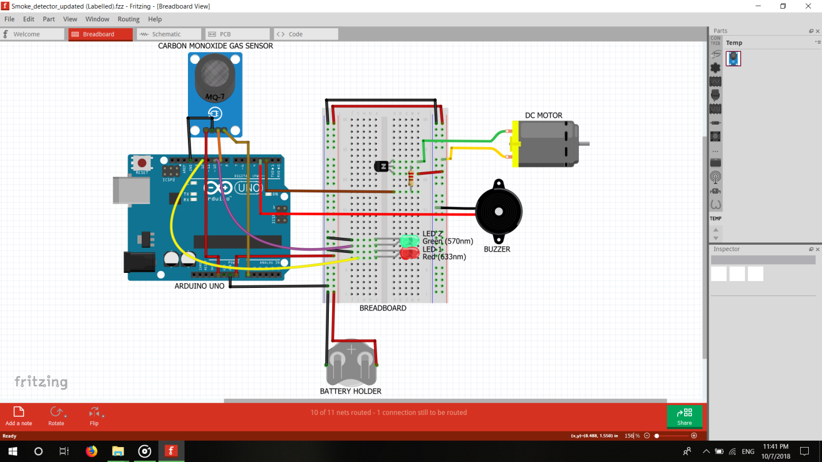

**CAD MODEL**

**Materials required**

* 5 mm MDF sheet
* Brass nuts
* 3 mm nuts and bolts
* Fevicol and Feviqwik
* Glue gun
* Water tank
* Water pipe

**Method**

* Cut six pieces of 150mm*150mm of MDF sheet.
* Cut two pieces of 150mm*40mm each of MDF sheet and acrylic sheet.
* Using L-angle, Fevicol, Feviqwik and glue gun, make two top open boxes as shown in figure.
* Connect water pipe to water tank and secure it using glue gun.
* Connect circuit to box and secure it.

**FUTURE SCOPE**

Fire hazards are not uncommon. In order to avoid damage from fire accidents, smoke detectors are installed at high-security places. These smoke detectors detect smoke as the fire breakout and invoke an early alarm. This way, before the fire spreads to other parts of the building, people can be evacuated and countermeasures can be done immediately. In this project also a smoke detector has been designed.

The smoke detector developed in this project not only invokes an alarm but also activates an exhaust fan so that smoke could be removed with immediate action. For the demonstration purpose instead of the actual exhaust fan, a DC motor has been operated in the project. The concentration of smoke is detected by the MQ-6 sensor and displayed on an LCD display. When the concentration of smoke reaches a dangerous level that can be an indication of a fire breakout, a LED indicator is activated.